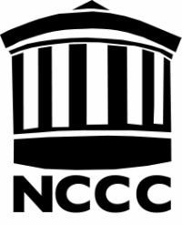NOTE-TAKING REQUEST FORM Northwestern Connecticut Community College Park Place East, Winsted, CT 06098

Student ID @

Name _
Last First

Home Phone
Cell Phone

Email
Major

Semester Registering for: (Circle One) Fall Winter Spring Summer Year

CRN | Course  Number | Course Title | Accom  - See codes Below | Day/s | Time: From-To | Room  No | Instructor

Support Service Codes:

1 = Note-Taker Services
2 = No services requested for this course

I agree to inform Christine Woodcock, the Counselor for Students with Disabilities if there are any changes to the above request.

Student Signature
Date

Rev 4/5/11

