Sexual Assault and Interpersonal Violence on Campus

WHAT YOU NEED TO KNOW

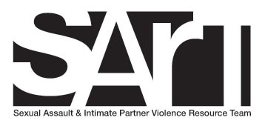

Table of Contents

UNDERSTANDING SEXUAL/INTERPERSONAL VIOLENCE 1
WHAT IS SEXUAL ASSAULT? 1
WHAT IS STALKING? 1
WHAT IS SEXUAL HARRASSMENT? 1
WHAT IS INTERPERSONAL VIOLENCE? 2
TYPES OF ABUSE 3
CONSENT 3
Consent is: 3
Consent is NOT: 4
HOW CAN I HELP STOP SEXUAL ASSAULT VIOLENCE? 5
Proactive Bystander Intervention 5
Reactive Bystander Strategies 5
YOUR RIGHTS 6
REPORTING OR DISCLOSING SEXUAL ASSAULT, SEXUAL HARASSMENT, DATING OR INTIMATE PARTNER VIOLENCE, OR STALKING TO NCCC 7
RESOURCES 8
PUBLIC NOTICE OF NONDISCRIMINATION 10

UNDERSTANDING SEXUAL/INTERPERSONAL VIOLENCE

WHAT IS SEXUAL ASSAULT?
Sexual Assault is compelling by force or by threat of force the following: sexual penetration of the vagina or anus, including by an object; oral sex; or contact with a person’s genital area, groin, anus, inner thighs, buttocks or breasts for the purpose of sexual gratification of the actor or for the purpose of degrading or humiliating the victim.
Sexual assault is also intentionally subjecting another to such contact without consent. Any person can be a victim or perpetrator.
Examples of sexual assault include: rape, attempted rape, intentional touching without consent of a person’s genital area, groin, anus, inner thighs, buttocks or breasts for sexual gratification or to degrade the victim.

WHAT IS STALKING?
Stalking is any behaviors or activities occurring on more than one (1) occasion that collectively instills fear in the victim and/or threatens her/his safety, mental health and/or physical health. Such behaviors or activities may include, but are not limited to, whether on or off campus, non-consensual communications face-to-face, telephone, email, Facebook, etc., threatening or obscene gestures, surveillance or being present outside the victim’s classroom or workplace.

WHAT IS SEXUAL HARRASSMENT?
Sexual Harassment is a form of unlawful gender-based discrimination. It may involve harassment of women by men, harassment of men by women, and harassment between persons of the same sex. Sexual harassment is defined as unwelcome gender-based verbal or physical conduct that is sufficiently severe, persistent, or pervasive that it unreasonably interferes with, limits or deprives someone of the ability to participate in or benefit from the college’s educational program or activities or employment benefits or opportunities. The unwelcome behavior may be based on power differentials such as quid pro quo harassment where submission to or rejection of unwelcome sexual conduct by an individual is used as the basis for employment or academic decisions, the creation of a hostile environment or retaliation.
Examples of conduct which may constitute sexual harassment include but are not limited to:
- Sexual flirtation, touching, advances or propositions
- Verbal abuse of a sexual nature
- Pressure to engage in sexual activity
- Implied or overt threats of punitive action, a result of rejection of sexual advances
- Graphic or suggestive comments about an individual’s dress or appearance
- Use of sexually degrading words to describe an individual
- Display of sexually suggestive objects, pictures or photographs
- Sexual jokes
- Comments based upon gender
- Threats, demands or suggestions that retention of one’s educational status is contingent upon toleration of or acquiescence in sexual advances.

WHAT IS INTERPERSONAL VIOLENCE?
Relationship Violence may be present in dating and domestic violence, sometimes also called intimate partner violence. It is a pattern of behavior in which one partner uses fear and intimidation to establish power and control over the other partner, often including the threat or use of violence. This abuse happens when one person believes they are entitled to control another and it may or may not include sexual assault.
Dating and domestic violence occur in straight/heterosexual relationships, same-sex/gender relationships and in intimate relationships that do not involve romantic feelings. Intimate partner violence impacts people of all ethnicities, races, classes, abilities, and nationalities.
Although there are some general patterns in domestic or dating violence, there is not typical abusive behavior. To wear down and control his/her victim, an abuser may use isolation, emotional harassment, physical contact, intimidation or other means. The controlling behavior usually escalates, particularly if the victim of the abuse tries to resist or leave.

TYPES OF ABUSE

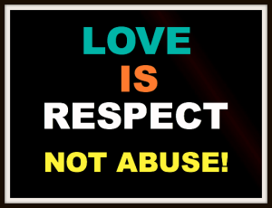
In a violent relationship, behaviors that are used to maintain fear, intimidation, and power over another person may include threats, intimidation, and economic abuse, sexual abuse, taking advantage of male privilege, or using someone’s identity against them. These behaviors may take the form of physical, sexual, emotional, and psychological violence.

CONSENT
An important concept for all of us, regardless of age, is one of consent. Consent is the most misunderstood concept in comprehending the issues around interpersonal violence. Learning how to talk about consent, gain consent and refuse consent, can help clarify each person’s responsibility to minimize the risk of unwanted sexual contact.

Consent is:
- a voluntuary, sober, informed, mutual, honest and verbal agreement
- an active agreement. Consent cannot be coerced.
- a process, which must be asked for every step of the way. If you want to move to the next level of sexual intimacy, you should ask!
- never implied and cannot be assumed, even in the context of a relationship. Just because you are in a relationship does not mean that you have permission to have sex with your partner.

Consent is NOT:
- If someone says no repeatedly and finally says yes
- If someone is incapacitated by substances
- If someone has only agreed to an earlier act
- If someone says nothing
- If someone is never asked for consent
- If someone has been made to feel that they must say yes
- If someone uses their position of power or authority to coerce or manipulate someone into saying yes
How do you know that someone has given consent?
The only way to know for sure if someone has given consent, is if they tell you. It’s not always easy to let people know that you are not happy about something. Sometimes the person you’re with might look like they are happy doing something, but inside, they are not. They might not know what to say or how to tell you that they are uncomfortable. One of the best ways to determine if someone is uncomfortable with any situation, especially with a sexual one, is to simply ask.

HOW CAN I HELP STOP SEXUAL ASSAULT VIOLENCE?

Sexual assault and interpersonal violence are complex and very real issues on and off campus. In order to address this reality, all members of the campus community and relevant off-campus support agencies, must work together. Everyone has a role to play in ending sexual violence. To prevent gender-based violence, it is important that people are approached as potential witnesses or bystanders to behaviors related to sexual or dating violence.

Proactive Bystander Intervention
In order to be a proactive bystander who helps prevent incidents of sexual violence, you can…
- Believe violence is unacceptable and say it out loud.
- Talk openly with your friends about these issues.
- Use the resources listed in this brochure to inform yourself.
- Don’t laugh at sexist jokes or comments.
- Empower victims to tell their stories.

Reactive Bystander Strategies
In order to be a reactive bystander who positively intervenes in instances of sexual harrassment or violence, there are certain ways you can step up to prevent a risky situation from resulting in an assault.
- Assume responsibility of intervening.
- Don’t be afraid to get involved.
- Get help from friends.
- Get help from campus authorities for
support and options.
- Ask the person who is in a potentially
dangerous situation if she/he wants to
leave.

YOUR RIGHTS
You have the right to…
- Be treated with respect and dignity.
- Privacy. This means you can refuse to answer any questions about the sexual assault, your sexual orientation, your sexual history (including HIV status), and your medical history.
- Be notified of existing campus and community based medical counseling, mental health and victims of sexual assault resources, whether or not the crime is formally reported to campus or civil authorities.
- A timely disposition if reporting an incident to the College.
- Be notified of the outcome of the College’s sexual assault conduct proceedings against the accused.
- Have conversations with a member of the Sexual Assault Resource Team (SART).
- Have access to local sexual assault crisis service center.
- Have access to a local domestic violence agency.
- Have a counselor/advocate to accompany you to medical and legal proceedings.
- Decide whether or not you want the police to investigage the assault.
- Request that someone you are comfortable with stay with you in the medical examination room.
- Ask questions and get answers regarding any tests, exams, medications, treatments or police reports.
- Not be judged on your race, age, class, marital status, gender or sexual orientation.
- Be considered a victim/survivor of sexual assault, regardless of the offender’s relationship to you.

Additional information regarding sexual misconduct and campus policies is available at www.nwcc.commnet.edu and on postings throughout the campus.

REPORTING OR DISCLOSING SEXUAL ASSAULT, SEXUAL HARASSMENT, DATING OR INTIMATE PARTNER VIOLENCE, OR STALKING TO NCCC

- Report incident to Dr. Patricia Bouffard, Dean of Academic & Student Affairs, 860.738.6319 pbouffard@nwcc.edu and/or Title IX Coordinator, Dr. Ruth E. Gonzalez, Director of Student Development, 860.738.6315 rgonzalez@nwcc.edu

- Depending on the nature of the complaint and the desires of the complainant, the College official to whom the complaint has been made may attempt to resolve the complaint informally. If informal resolution is not possible or appropriate, a written complaint should be filed in accordance with the the Student Grievance Procedure.

- Written complaint should be filed within thirty (30) days of the date the grievant knew or should have known of the alledged harrassment. A written complaint will be treated in the manner prescribed by this policy if filed within 180 days of the date the student knew or should have known of the alleged harassment.

- When a formal complaint of sexual harassment is received, the College will investigate. The rights of all persons involved in the investigation shall be respected and every effort will be made to protect the confidentiality of both the alleged victim and the alleged harasser. However, complete anonymity cannot be assured, given the College’s obligation under law to investigate and take appropriate action in all cases of sexual harasment.

- A request for review by the College President may be made within three (3) business days of receiving notice of determination.

- If you witness an assualt on campus, immediately call 911.

RESOURCES
NCCC SART:
Ruth E. Gonzalez, Ph.D. 860-738-6315 GW 220
Susan Berg 860-738-6342 GW 223
Kathleen Chapman 860-738-6344 GW 110
Michael Emanuel 860-738-6389 FH 308
Gary Greco –CEDHH 860-469-3138 (VP) FH 101
860-738-6397 (V)
Jane O’Grady 860-738-6393 FX 212
Robin Orlomoski 860-738-6416 Business 201
Savannah Schmitt Student Representative
Jacob Wujcik Student Representative
Patricia Bouffard, Dean 860-738-6319 FH 103
of Academic & Student Affairs

Confidential Community Members:
Susan B. Anthony Project 860-482-7133 Hotline www.sbaproject.org

Charlotte Hungerford Hospital 860-496-6666
CT Sexual Assault Crisis Services 888-999-5545
888-568-8332
Winsted Police Department 860-379-2721
Torrington Police Department 860-489-2000
CT State Police Dispatch (Troop L) 860-626-7900
CT State Police Dispatch (Troop B) 860-542-5249
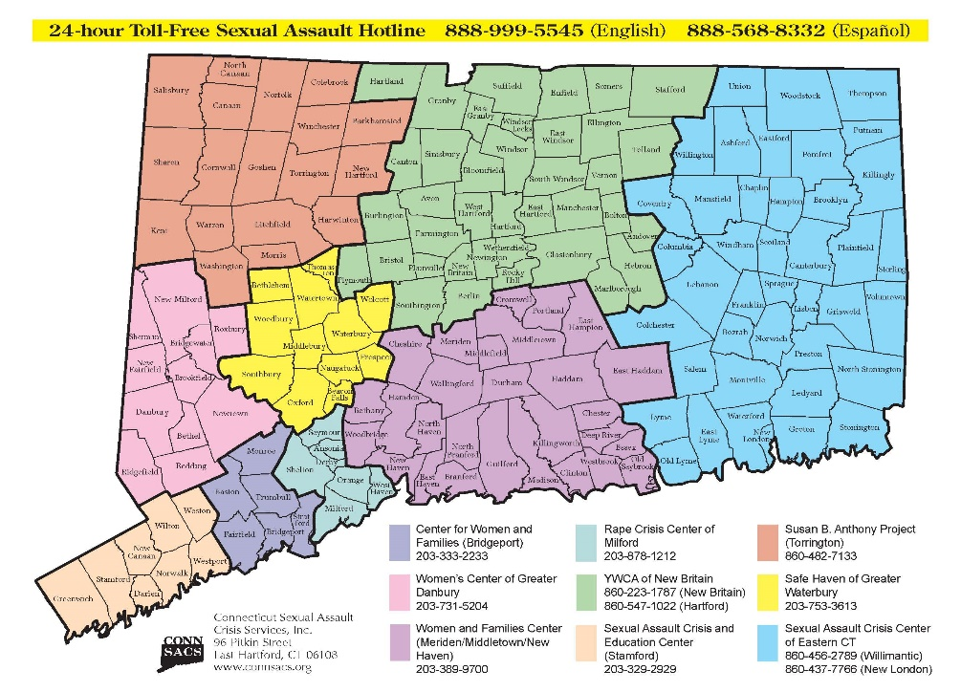

PUBLIC NOTICE OF NONDISCRIMINATION
Northwestern Connecticut Community College does not discriminate on the basis of race, color, religious creed, age, sex, national origin, marital status, ancestry, present or past history of mental disorder, learning disability or physical disability, veteran status, sexual orientation, gender identity and expression, genetic information or criminal record in its programs and activities.
The following person has been designated to handle inquiries regarding the non-discrimination policies: Dr. Ruth E. Gonzalez, Director of Student Development, (Title IX and Section 504/ADA Coordinator) Northwestern Connecticut Community College, Park Place East, Winsted, CT 06098, Green Woods Hall, Room 207 (860) 738-6315, rgonzalez@nwcc.edu.

NORTHWESTERN CONNECTICUT COMMUNITY COLLEGE • Park Place East, Winsted, CT 06098 • Phone: 860-738-6300 www.nwcc.commnet.edu

