$10

CERTIFIED NURSING ASSISTANTS

$1000 SIGN ON BONUS

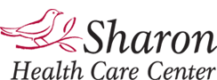

Sharonhcc.com
(860)364-1002

