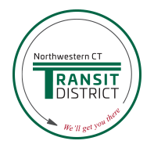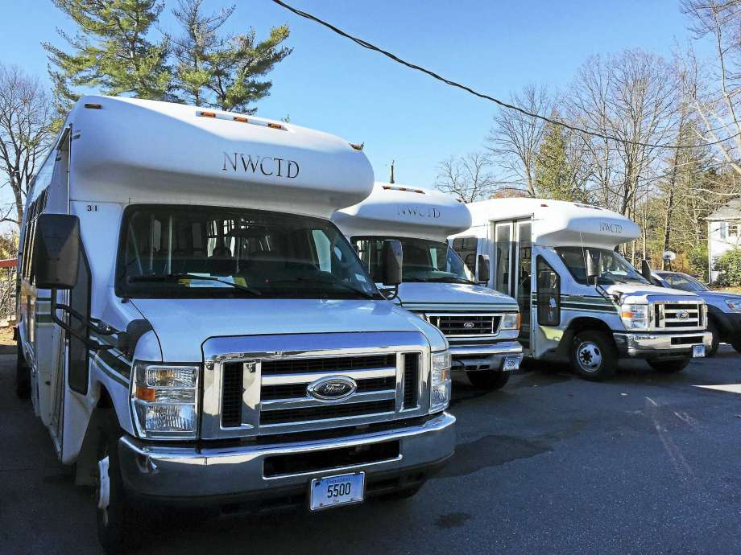
Northwest Transit District Is Hiring!!
DRIVERS WANTED!!
Full and part-time positions available
Service Area
Northwest Connecticut Transit District is a local transit service that offers both door to door and fixed route transportation. Towns served include Barkhamsted, Canaan, Colebrook, Cornwall, Falls Village, Goshen, Harwinton, Kent, Litchfield, Morris, New Hartford, Norfolk, Salisbury, Sharon, Torrington, Warren, and Winchester & Winsted.
Job Description
Transit bus drivers needed! Must have a public service license or be willing to obtain one. CDL license is helpful, but not a must. Non CDL drivers must have a V or F endorsement. CDL drivers must have a P and either an F or V endorsement. Potential hired drivers will be subject to a drug test, background check and will need an up to date medical card. Drivers are responsible for sanitizing their busses to maintain a sterile and virus free work area.
Part-time hours: 25 – 30 hours per week
Salary: From $16.00 per hour
COVID-19 considerations: To keep our passengers and drivers safe, we’ve installed clear plastic barriers, masks, gloves, sanitizer and disinfectant sprays.
PLEASE APPLY IN PERSON @ NWTD, 957 East Main Street, Torrington, CT, Monday through Thursday, 6 am -1pm, or Friday 6am-noon. Ask for Dee or Leron Williams. Inquiries may be made to (860) 489-2535.

