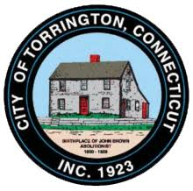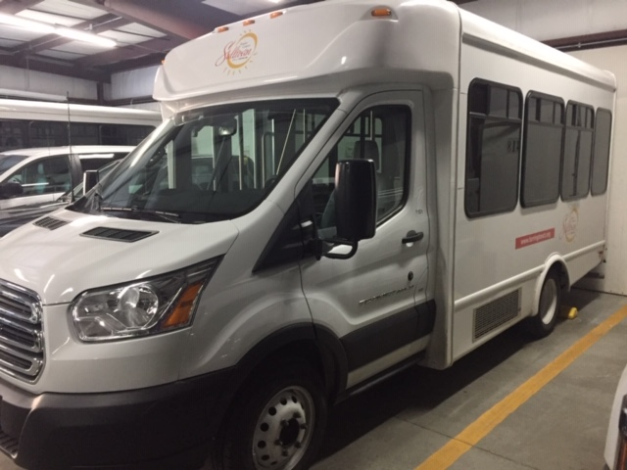
Torrington Sullivan Senior Center Assisted Medical Transportation Van
Is Hiring!!
DRIVERS WANTED!!
Part-time positions (Flexible schedule)
Medical Transportation
Assisted Medical Transportation for Seniors (Door to door service)
The Assisted Medical Transportation Program is a dial-a-ride service provided by the City of Torrington Sullivan Senior Center to qualified seniors (and residents with disabilities) seeking rides to various medical facilities in the towns of Torrington, Litchfield, Harwinton, and to the VA Clinic in Winsted.
Job Description
Drivers Needed! Willing to train but MUST HAVE have a current, valid driver’s license with a Public Service Endorsement, a current Medical Examiner’s Certification and must be able and willing to assist clients up/down stairs, onto lift (if necessary) and with wheelchair and securements. Potential hired drivers subject to drug and background screenings. Drivers are responsible for sanitizing their busses to maintain a sterile and virus free work area.
Part-time hours: Monday – Friday between 8:00 am and 5:00 pm
PLEASE APPLY ON-LINE @ https://www.torringtonct.org . For inquiries, contact the Torrington Sullivan Senior Center directly @ (860) 489-2211.

